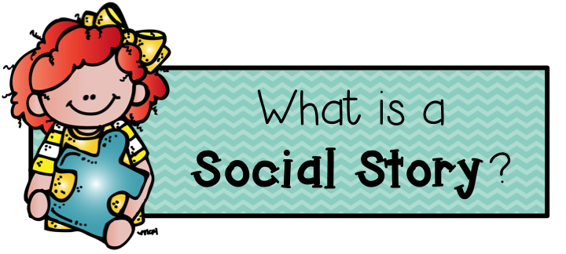

SOCIAL STORIES
Definition

Social Stories are:
- A way to develop children’s understanding of situations that they find difficult (by helping to explain what happens and to help them to understand things from other peoples’ point of view).
- A way of communicating to the child what the expectations are (i.e. how to behave in social situations); not designed to change a child’s behaviour but to increase their understanding in the hope of encouraging appropriate responses to their environment (The Gray Center, 2011).
- An effective way of preparing pupils for change, i.e. transition.
- Helpful for any child who finds change unsettling.

Evidence base for Social Stories

Much of the initial research around social stories focused on children with Autism. However more recently there has been recognition that children with emotional and behavioural difficulties also need support to understand and know how to act in social situations, and to prepare for changes.

Toplis & Hadwin (2007):
- Used social stories with Year 2 children who were on the SEN register due to behavioural difficulties – particular difficulties at lunchtime.
- LSA read the story with each child for 10 minutes every day (for 5 days) before lunchtime.
- 3 out of 5 children showed a significant improvement in behaviour when their social story was introduced and some reduction in desired behaviours when the story was withdrawn.
- Suggested that the story possibly wasn’t used for long enough, which is why two of the children didn’t show any improvement. Also proposed that these children needed to be explicitly taught skills alongside the story.

Whitehead (2008):
- Used social stories with Year 4 children who were on the SEN register due to having social, emotional or behavioural difficulties.
- Pupils and adults felt that they were quick and easy to use.
- Many pupils said that they enjoyed reading the positive, affirming comments about themselves.
- There were some pupils who didn’t like certain aspects of their story (i.e. comments that they perceived as negative, pictures that they didn’t like) and so it was important for the adult to adapt the story rather than stop using it.
- Particularly helpful for pupils who had difficulty with taking the perspective of others.

Benish & Bramlett (2011):
One teacher commented that by using a social story intervention, she was being “given the chance to connect one-on-one” highlighting the personable aspect to using social stories.

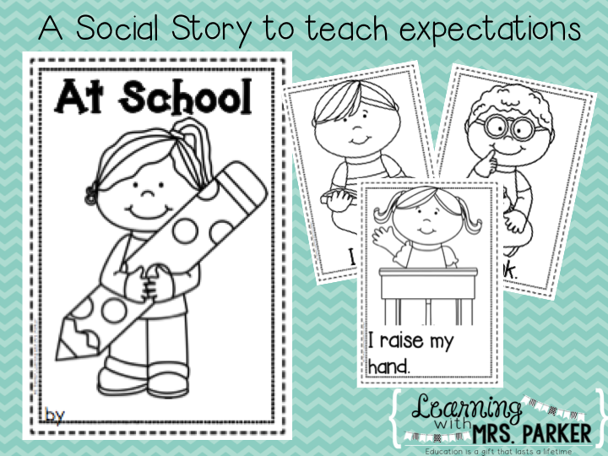
Tips for making up Social Stories

- A social story describes very specifically what happens and why, and usually tells the child the desirable way to behave.
- It is written in consultation with pupil/parents/adults and after careful observation of target situation. Vocabulary and presentation should be appropriate to child’s age and ability.
- Usually written in the first person and present tense.
- Can be personalised by appropriate inclusion of pupil’s interests - should be attractive and interesting (i.e. include pictures of things that the child is interested in).
- Not a simple list of what to do - include sentences describing where a situation occurs, who is involved, what they are doing and why.
- Describes and explains the reactions and feelings of others.

Basic social stories use three types of sentence (according to Gray, 1994):
- Descriptive - what happens, where the situation occurs, who is involved, what they are doing and why
- Perspective - describing the reactions and responses of others in the target situation, sometimes the reasons for their responses, and may describe the feelings of others
- Directive - describe desired responses to social situations. They tell the child in positive terms what he or she should try to do or say in the target situation

Ratio – there should be 3-5 descriptive and/or perspective sentences to every directive sentence.

Words such as ‘usually’, ‘sometimes’ and ‘probably’ are often used to help child avoid over-literal interpretation and cope with exceptions - as children with social communication difficulties often interpret language literally, it is important to avoid statements that are inflexible. Preferable to use terms such as “I will try to…” rather than “I can…” or “I will..”, both of which require absolute compliance.

Stories are only as long as they need to be (keep to the point) - better to write separate stories for different issues than try to put too much into one.

Generally end with a positive affirmation - (e.g. I am a hard worker, I am a helpful person, I try my best); helps the child feel good about themselves while learning new behaviours.

The pupil reads the story (or listens on audiotape) before the target situation arises, e.g. daily before playtime / assembly.

Daily access to the story should continue as long as the pupil wants or needs - Use the story as often as necessary until the new behaviour becomes part of the child’s repertoire…..and hang on to it in case the child needs a future reminder.


Example Social story
Sometimes children like to talk to each other during break times and after school.

Children like to talk about things that interest them.

Children are interested in different things from each other.

Sometimes other children aren’t as interested in a topic as we are.

It is helpful to ask children questions to find out what they are interested in, how they are feeling and what they have been doing recently. Other children like it when we do this as it shows we are interested in them.

Talking about things that they are interested in can help children to be friends and find out what they have in common.

I will try when I am with other children to think about what they may want to talk about and ask them questions that show I am interested in them.

Dr Turner, 2017

